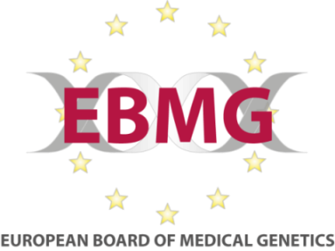
European Curriculum for MSc Genetic Counselling
Form H. Application for course renewal

Master courses that have been approved by the EBMG as suitable for the education and training of genetic counsellors or genetic nurses should be reassessed on a three yearly basis according, to the European core curriculum for Master programmes.
The required elements for genetic counsellor training are related to practical components of the master course, the practical preparation – through practical clinical placements; how the course enables students to acquire knowledge and competences in counselling practice and psychosocial issues involved, medical and human genetics as well as ethics, law and psychosocial aspects of genetic healthcare. The established standards also require that there are adequate opportunities for students to conduct critical appraisal of relevant research evidence and provide education to patients and other health professionals.

We are now inviting you to renew the accreditation of the master course being delivered at your University. Please complete this form and submit with the following documents:
- Evidence of current course validation by your institution
- Course entry requirements
- Student selection methods
- Full curriculum, including content of each course or module
- Methods of assessment.
- The student handbook.

You may also submit other documents you think will be helpful to us during the renewal process.
Please indicate if there have been any substantive changes made after the accreditation in (2012), especially regarding the course entry requirements, student selection methods, curriculum or methods of assessment.
Yes: ___ No: ___
If appropriate, please refer to specific pages in your course documents.

Signed

Date

